The following instructions can be used by a staff or student of UNSW to set up forwarding of their emails to an account outside of UNSW.
- Self-service management of email forwarding is currently carried out via the UNSW Identity Manager (IDM) which is accessible using a current password via the URL: idm.unsw.edu.au
- The home page when accessed should appear as below:
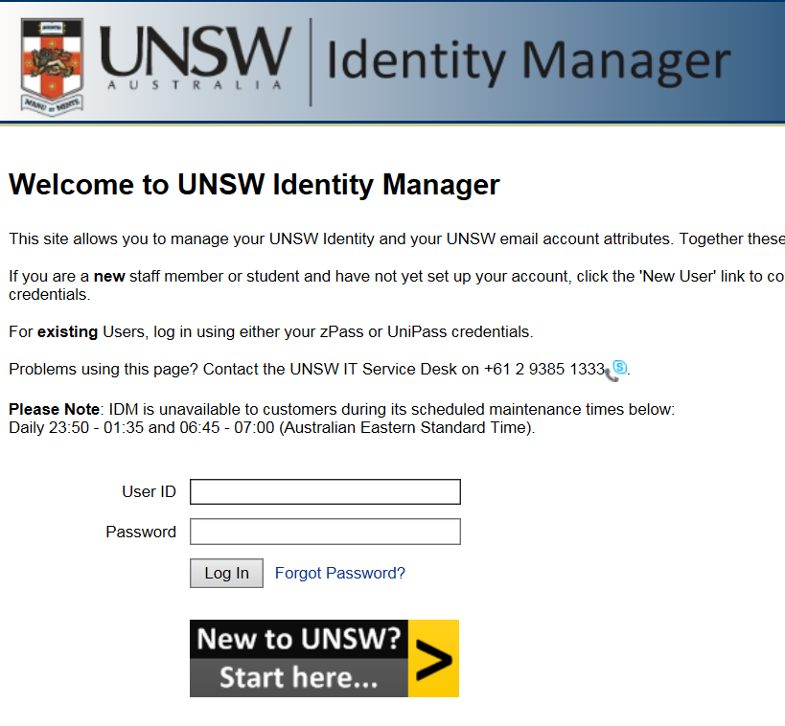
Please note the planned outage times for when the site will not be available.
- Log in with your current username and password
- Once logged in, scroll to the ‘UNSW Email’ section:
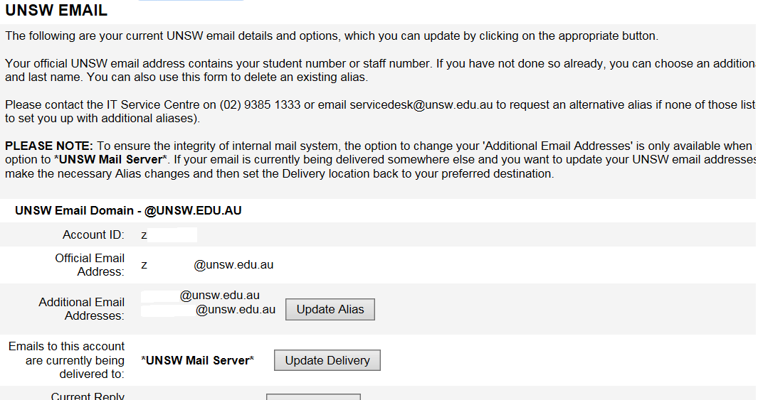
- Click on ‘Update Delivery’ next to ‘Emails to this account are currently being delivered to:’
  - The text here would say *UNSW Mail Server* if emails are currently being delivered to your UNSW mailbox.
- On the page that loads, select the radio button for ‘Other Alternative Mail System’, enter your ASU or other email address and click ‘Save Change’ to apply this update.
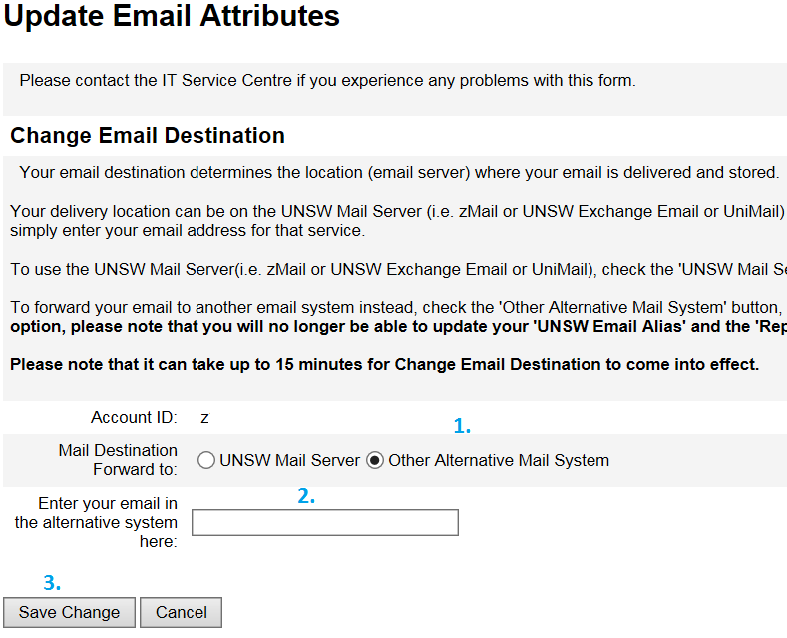

Things to note:
  - This setting takes approximately 15 minutes to take effect.
  - With this forwarding in place emails are routed directly to the external mailbox and no copy is kept at UNSW.

